Hello Eline, good morning, how are you? Thank you again for be willing to organize this meeting and help us.

As Fernando mentioned in his mail, we are looking for the most effective treatments to reduce mortality in hospitalized patients with Covid-19, (optional: those that serve us the most are those with data from clinical trials or hazard ratios.)

Optional (If you want, First, I will explain a little what we are doing and why we need this information and then I ask what are we looking for specifically. Are you ok with this?)

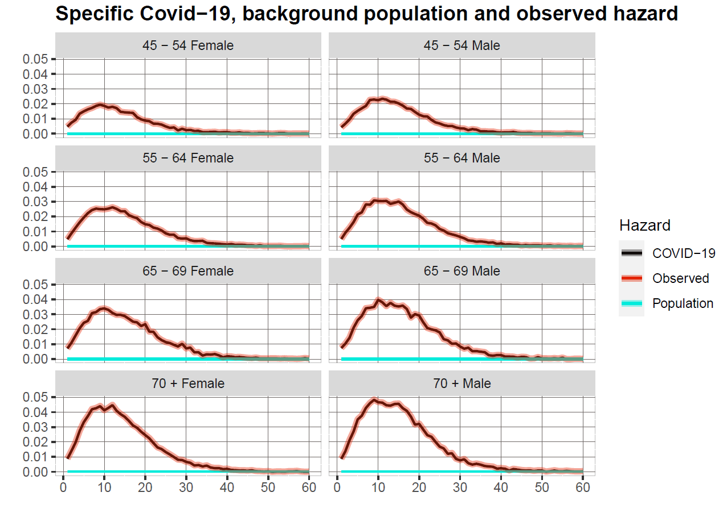

First, we calculate Covid-19 specific hazard (red line) for covid-19 hospitalized patients reported by the Mexican government. This is calculated comparing the expected background mortality for a certain age and sex group (blue line) in a specific period and the observed hazard in a cohort of hospitalized patients with covid-19 (black line). The difference between the observed hazard and background population hazard is the Covid-19 specific hazard (red line).

Then, we apply the reduction of Covid-19 hazard for each treatment, obtained by the data of clinical trials and hazard ratios reported in studies of hospitalize patients with Covid-19.

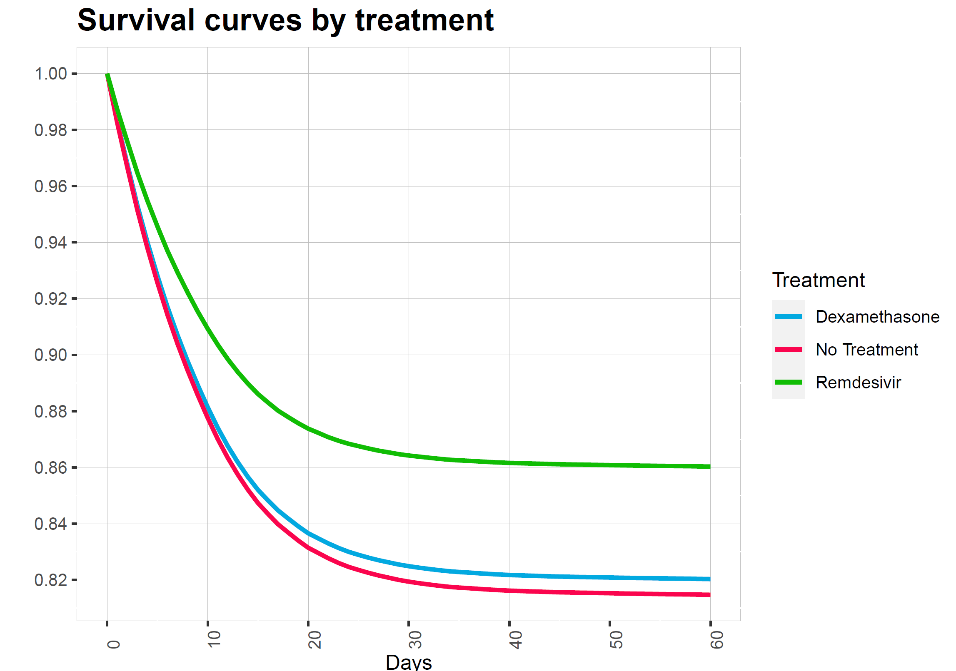

These are simulated survival curves by treatment that consider the reduction of hazard by each treatment. The idea is making this simulation for each relevant treatment to reduce mortality in hospitalized patients and make a cost-effective analysis the results of the microsimulation.

Right now, we are working with dexamethasone. We have also analyzed remdesivir and looked for other treatments such as monoclonal antibodies or convalescent plasma, the problem is that we found conflicting evidence for these treatments.

So, we wanted to ask you which are the ones that you recommend us to evaluate, which ones are the more relevant or with the most promising evidence?

(Optional: Also, if you could tell me what is the literature that you are considering to recommend these treatments)

(Optional: Can you offer me guidance on which are the most relevant to consider, not necessarily just for hospitalized patients)

(Optional: Do you know if all these treatments have an estimated price, even if it is only in certain countries or something announced by the pharmaceutical companies).

https://www.drugs.com/price-guide/rebif

8749 USD for Refib, 44mcg/0.5mL, price for 6 mL, divide by 12 for 1 dosage